CreateElement/AJAX/REST/JSON Lab
Objectives
In this lab, we will learn how to:
- Send information from a web page to PHP using REST
- Use PHP to query a database
- Retrieve data from PHP into a web form using AJAX and JSON
- Dynamically change a web page using createElement.
Exercise 1: Using REST to Query a Database
Log into webhost. Select Tools, Database Manager.

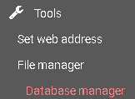

Select New Database 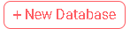

When you create the database, it will not actually give it the name you define. Instead, that name will be appended to a string of digits. In my case, the database is id11304588_amazonia. However, since I created my account, webhost has updated its security. Call your database myamazonia, your username <loginid>amazonia and set your password to Stupidsecurity0!.

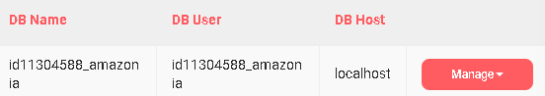

Regardless, make sure that whatever you put as the database name, username and password, you know what it is. We will need this information later.

Now click Manage\PhpMyAdmin

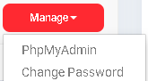

In PhpMyAdmin, click on the database. In my case, it is id11304588_amazonia. Click Import.

Choose File Amazonia.mysql.

Format should be SQL (default). SQL compatibility mode: MySQL 40
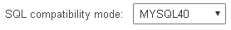

Click Go.

If successful, your database should be populated by at least 10 tables.
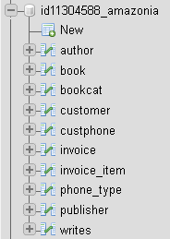

Exit out of phpMyAdmin and go back to WebHost. You should now have your Amazonia database installed.
Create a file called books.php
A PHP REST module begins with <?php and ends with ?>.
In books.php, type the following:
<?php
echo 'Hello World';
?>
If you are successful, your screen should look like this:
A PHP module receives information from the web via the $_REQUEST[] container. All PHP variables are prefaced by a $ sign. We are going to receive two variables from the web- title, and sort. Change your code now as follows:
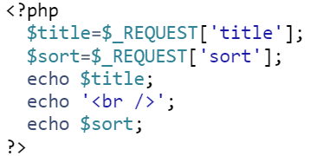You pass information to PHP by putting a question mark at the end of the file name and then putting a sequence of variable value pairs separated by an ampersand (&). Thus, you would say:
http://<your domain>/<your directory>/books.php?title=data&sort=title
Try this now:
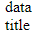
A database query in PHP has three parts. First, you create a PHP Data Object (PDO). This is a connection to the database. Your PDO must include the database driver, the URL to the database, the database name, the username and password. Next, you prepare the SQL query. Finally, you execute it.
Typically, the results of your query are to be sent out in JavaScript Object Notation (JSON) format.
Change your PHP code so it looks like this:
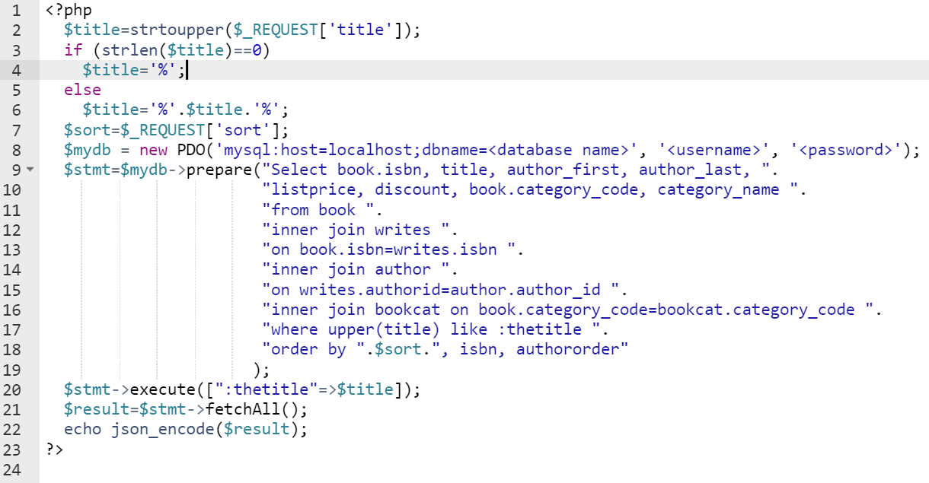
Here’s what the code does.
Line 2: Read the title from the web and capitalize it.
Line 3-6: If the title is empty, change it to %. Otherwise put % in the front and end of the title. % is the wildcard character in SQL. By putting % in front and back it means we are looking for any occurrence of that word in the title.
Line 8: Connect to the database
Line 9-19: The SQL statement. NOTE THE EMPTY SPACE BEFORE THE QUOTES AND THE PERIOD AT THE END OF EACH LINE. They are important. Note the sort variable embedded in the query. This is actually a security risk. Unfortunately, at this time, PDO does not easily allow parameters to be passed to an order by clause.
Line 20: Run the SQL query using title in place of the parameter thetitle. By rights, we should do this with sort, but PDO does not allow this.
Line 21: Retrieve the SQL results into a PHP variable called result
Line 22: Convert result to JSON and send it to whoever requested it.
If you did this correctly, you should see:
Try this with a number of different titles and sort orders to see what happens.
Note: If you get some kind of notification with the word “Notice” in it, put this as the FIRST line in your PHP code (i.e., immediately following the <?php:
error_reporting(E_ALL & ~E_NOTICE);
This turns off all notices.
Exercise 2: Retrieve REST results into JavaScript using AJAX.
Create a webpage in HTML called viewbooks.htm with the following code:
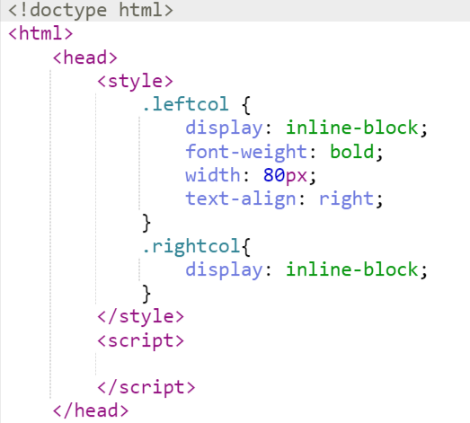
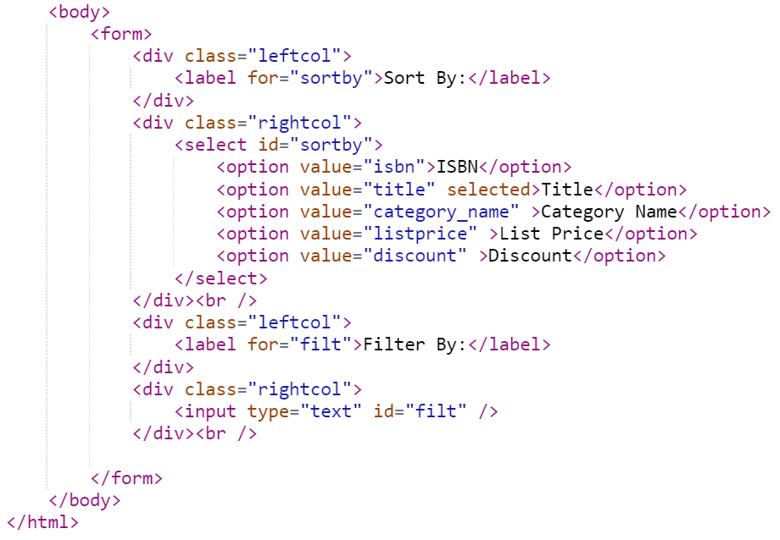
If you did this right, your screen should look like this:
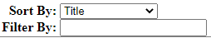
The main thing we want to observe is the pulldown, created by the select tag. This is the code for the pulldown
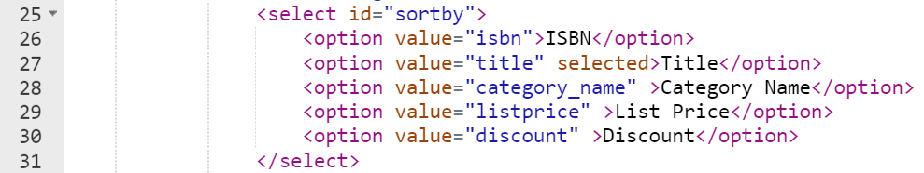Line 25: The pulldown is created by the select tag
Line 26-30: The options of the pulldown are created by the option tag. Also notice the value attribute. This is the information the option tag actually holds. The innerHTML is what is displayed to the user.
Line 27: The selected attribute identifies which option is currently selected.
Now, we are going to add a table. Add the following code just before the end form tag.
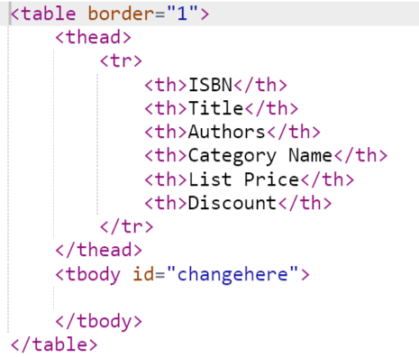

The ID changehere is especially important because we are going to work with this.
It is now time for us to do our AJAX magic. Create the following function:
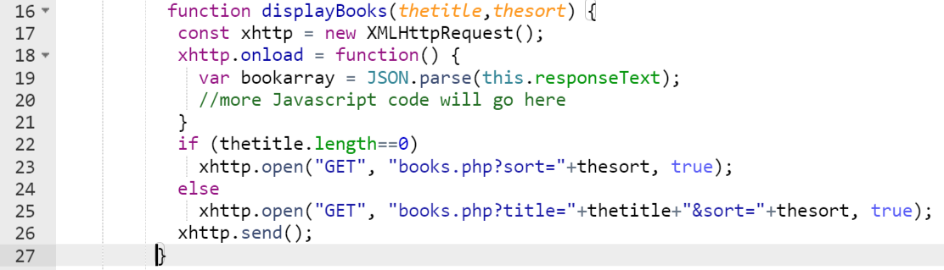
This is fundamentally the structure of AJAX code, which we explain below:
Line 17: Create an AJAX request.
Line 18-21: When the AJAX request receives something from PHP, do what is in the function. The returned value from PHP is found in this.responseText
Line 19: Convert what PHP returned from JSON to a variable
Line 23/25: Create the connection to PHP
Line 26: Actually perform the connection
The actual function we will apply is as follows. Replace the code that says //more Javascript code will go here with:
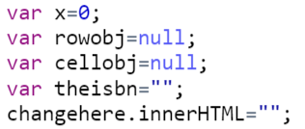
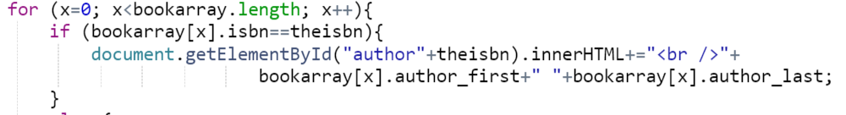
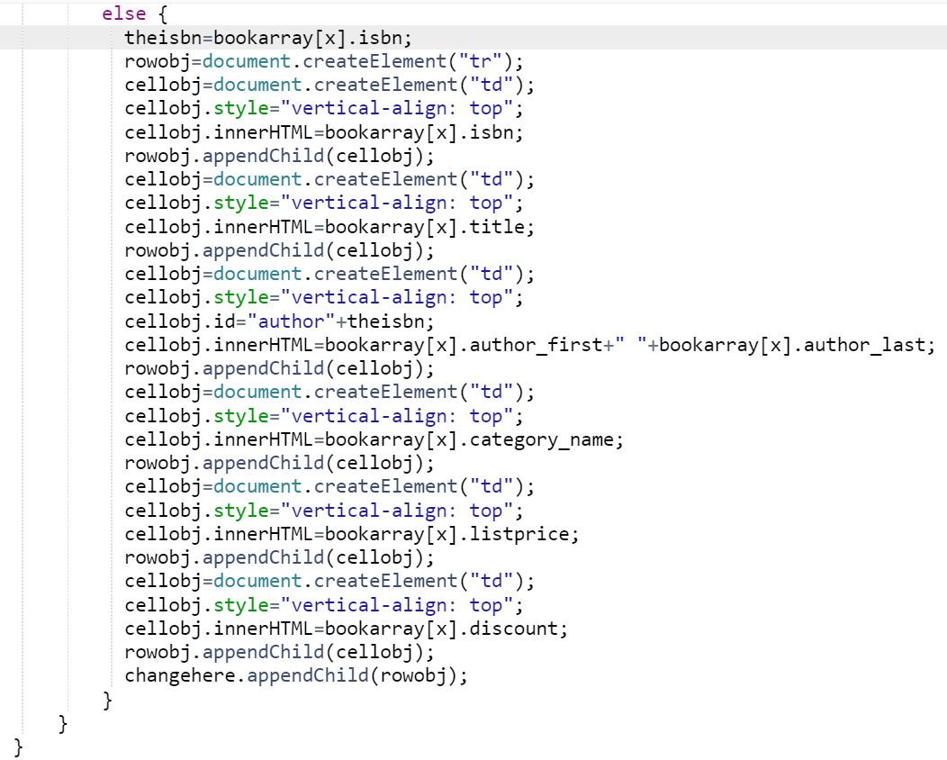

This is a lot of code, but it is quite repetitive. What we are doing is looping through the array of results returned from JSON.
We first blank changehere (changehere.innerHTML=””).
If the row has the same ISBN as the previous row, this means it is the same book. If so, just add the author to the correct column.
Otherwise, we use createElement to create a new row (tr). We add the ISBN, title, author, etc. cells to the row. We do this by usingcreateElement to create the cells (td). We then use appendChild to add it to the row. We then use appendChild to add the row to changehere.
Link the code to the onload event of the body tag:
Run your code. If you were successful, your screen should look like this:
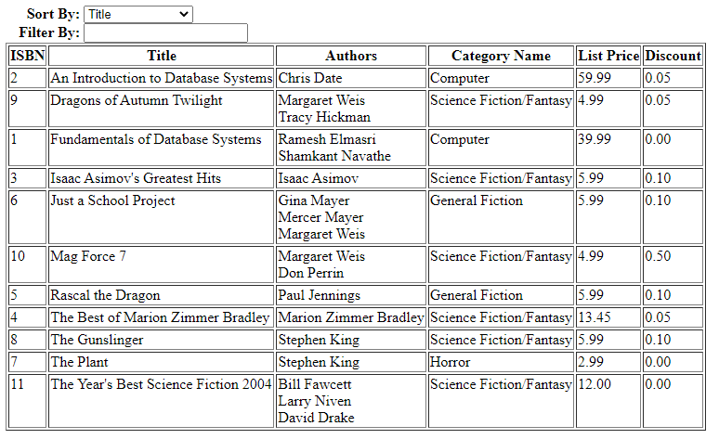
Now we have to link the code to the pulldown and the textbox. The event for a pulldown is onchange.
Set the onkeyup event of the textbox to do AJAX.
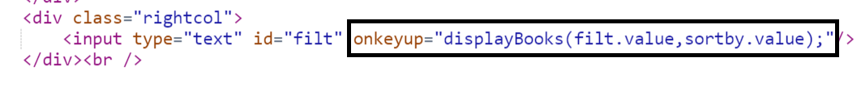If you did everything right, you should be able to do this:
